FULL PAPER TITLE FULL PAPER TITLE FULL PAPER TITLE FULL PAPER TITLE
Author 1, First Name Surname∗, Author 2, First Name Surname∗∗, Author 3, First Name Surname∗∗∗

Abstract
[Delete these instructions and write the English abstract here. The abstract should state clearly and concisely the purpose or principal research problem, the data or study group, the research method, the main findings, and the principal conclusion. It must contain 150–300 words and be presented as a single paragraph. Do not include citations, footnotes, tables, figures, or equations. Avoid uncommon abbreviations; when their use is necessary, define them at first mention. The English abstract must be consistent with the Turkish abstract in content and findings.]
Keywords: [First keyword], [Second keyword], [Third keyword] (3–5 keywords)

1. Introduction
[Delete these instructions and write the introduction. Define the study topic and research problem, and explain the study’s purpose, significance, scope, and originality. State the research questions or hypotheses clearly and identify the contribution the study is expected to make to the literature or practice. The final paragraph may briefly outline the remaining sections of the paper.]

2. Conceptual/Theoretical Framework and Literature Review
[Delete these instructions and present the conceptual or theoretical framework and literature review. Explain the principal concepts and theoretical approaches underpinning the study, and evaluate relevant national and international scholarship critically and comprehensively. Clarify the position of the present study by identifying similarities, differences, and the research gap in the literature. Numbered subsections may be used where appropriate.]

3. Methodology
[Describe the research design, target population and sample or study group, data sources, data collection instruments, analytical method, validity and reliability procedures, and ethical approval, where applicable.]

3.1. Research Design and Study Group
[Describe the study’s quantitative, qualitative, or mixed-methods approach; research design; target population, sample, or study group; sampling method; and scope.]

3.2. Data Collection and Analysis Procedure
[Identify the sources, instruments, and period of data collection, and describe the methods and software used to analyze the data.]

3.2.1. Data Collection Instruments
[Describe the data collection instruments, such as questionnaires, interview protocols, scales, observation forms, secondary databases, or documents. Report evidence of the validity and reliability of any scales used.]

3.2.2. Data Analysis
[Explain the statistical, econometric, or qualitative techniques used to analyze the data. Specify the software, stages of analysis, significance level, and model assumptions, where applicable.]

3.3. Research Model
[Explain the research or econometric model used in the study. Define the variables included in the model, describe how they are measured, and state the expected relationships among them.]

The relationship between the dependent and independent variables was examined using the following linear regression model:
$$\begin{matrix} & Y_{i}=β_{0}+β_{1}X_{1i}+β_{2}X_{2i}+β_{3}X_{3i}+ε_{i} & & \end{matrix}$$ | (1)

where $Y_{i}$ denotes the dependent variable; $X_{1i}$, $X_{2i}$, and $X_{3i}$ denote the independent or control variables; $β_{0}$ is the intercept; $β_{1}$, $β_{2}$, and $β_{3}$ are the coefficients to be estimated; $ε_{i}$ is the error term.

4. Findings and Discussion
[Delete these instructions and present the findings and their discussion. Report the findings clearly and objectively in an order aligned with the research questions or hypotheses, using tables and figures where appropriate. Explain the meaning of the findings, compare the results with previous studies, and discuss similarities and differences. Depending on the nature of the study, the findings and discussion may be organized under separate subheadings.]
Table 1. Descriptive Statistics
Variable | N | Mean | Standard Deviation | Minimum | Maximum
Average Years of Schooling | 30 | 10,80 | 1,29 | 7,77 | 13,72
Unemployment Rate (%) | 30 | 11,40 | 2,74 | 7,18 | 18,00
Income per Capita | 30 | 38.422,44 | 4.270,87 | 28.025,72 | 46.634,37
Social Exclusion Rate (%) | 30 | 24,36 | 4,35 | 15,03 | 32,58
Tertiary Education Attainment Rate (%) | 30 | 43,38 | 7,54 | 24,03 | 60,00
Note. The values reported in this table are illustrative data provided solely to demonstrate formatting.
Figure 1. Relationship between Average Years of Schooling and the Unemployment Rate
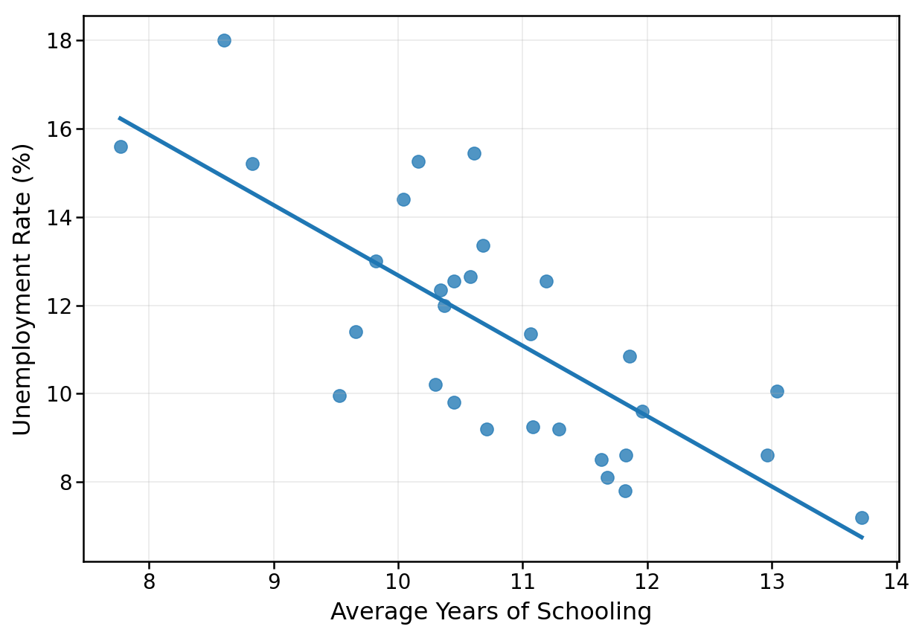
Note. The points represent observations, and the line indicates the linear trend between the variables.

5. Conclusion
[Delete these instructions and write the conclusion. Briefly summarize the study’s purpose and principal findings, and explain its theoretical, methodological, or practical contributions. You may include recommendations based on the findings, study limitations, and directions for future research. Do not introduce findings or analyses that have not been reported previously.]

References
[List all sources cited in the text in this section. Do not include works that are not cited in the text. Arrange references alphabetically by the authors’ surnames. List multiple works by the same author chronologically, from earliest to most recent. Present available DOIs in the https://doi.org/ format.]
[The references below are examples provided solely to illustrate APA 7 formatting. Descriptive labels such as “Journal article” and “Book” must not appear in the reference list.]

Single-author journal article
Kaya, C. (2023). The relationship between social media use and academic achievement among university students. Education and Society, 12(1), 45–62.

Two-author journal article with a DOI
Yılmaz, A., & Demir, B. (2024). The effect of digitalization on regional income inequality. Journal of Social Science Research, 19(2), 115–134. https://doi.org/10.xxxx/xxxxx

Journal article with three or more authors
Aydın, E., Çelik, S., Koç, M., & Arslan, T. (2022). Institutional quality and sustainable development: A cross-country analysis. Journal of Economics and Management Research, 10(3), 201–225. https://doi.org/10.xxxx/xxxxx

Single-author book
Arslan, M. (2022). Research methods in the social sciences (3rd ed.). Akademi Press.

Two-author book
Koç, A., & Şahin, E. (2021). Regional development and social policy. Bilim Press.

Edited book
Demir, H., & Yıldız, S. (Eds.). (2023). Digital transformation and social change. University Press.

Chapter in an edited book
Çelik, S. (2023). Migration and urban integration policies. In H. Demir & S. Yıldız (Eds.), Digital transformation and social change (pp. 85–108). University Press.

Webpage with an organizational author
Organization Name. (2026, March 12). Title of the webpage. https://xxxxx

Webpage with an individual author
Author, A. A. (2025, November 18). Title of the webpage. Website Name. https://xxxxx

Full paper published in conference proceedings
Güneş, T., & Eren, P. (2025). The effect of social capital on regional development. In M. Aydın (Ed.), Proceedings of the 4th International Congress on Social Sciences (pp. 125–139). Congress Press. https://xxxxx
Data set
Organization Name. (2025). Title of the data set [Data set]. https://xxxxx

Official APA 7 Reference Examples
For detailed guidance and examples of other reference types, see: APA Style – Reference Examples

PAGE LAYOUT AND FORMATTING REQUIREMENTS FOR FULL-TEXT PAPERS
- Full-text papers must be prepared using this template provided by the conference. The page layout, header, footer, page numbering, and predefined text styles must not be modified.
- The page size must be A4, with 2 cm margins at the top, bottom, left, and right.
- Authors must not modify the header containing the conference name and dates. Page numbers must appear automatically in the bottom-right corner of each page.
- The paper title must be set in 12-point Times New Roman, bold, centered, and in uppercase letters. It should be clear, concise, and accurately reflect the paper’s content.
- Authors’ first and last names must be set in 12-point Times New Roman, bold, and centered. Each author’s academic title, affiliation, email address, and ORCID ID must be provided in a footnote marked with an asterisk (*, **, ***). Author-information footnotes must be set in 10-point Times New Roman.
- The headings Turkish Abstract and Abstract, as well as first-, second-, and third-level section headings, must be set in 12-point Times New Roman, bold, and left-aligned. Section headings must use the capitalization pattern shown in this template rather than all uppercase letters.
- Main headings and subheadings must be numbered using the decimal system:
1. Introduction
3.1. Research Design and Study Group
3.2.1. Data Collection Instruments
- Headings below the third level are not recommended.
- The main text, Turkish and English abstracts, keywords, table and figure notes, and reference list must be set in 10-point Times New Roman.
- Text must be justified and single-spaced, with no first-line indentation. Do not add spacing before or after body paragraphs. Leave 12 pt of space before headings and no additional paragraph spacing after headings.
- The abstract must contain 150–300 words and be presented as a single paragraph. The abstract must state clearly the study’s purpose, scope or study group, method, principal findings, and main conclusion.
- Use the heading Keywords below the abstract, followed by 3–5 keywords. Both labels must be bold.
- Full-text papers must contain 3,000–5,000 words.
- In-text citations and the reference list must follow APA 7 guidelines. Every source cited in the text must appear in the reference list, and sources not cited in the text must not be included.
- Tables must be numbered in the order in which they are cited in the text. The table title must appear above the table, left-aligned, in 10-point Times New Roman and bold. Tables must be created as editable Word tables. Output from statistical or data-analysis software must not be pasted as a screenshot or image.
- Tables and figures must be numbered in the order in which they are cited in the text. Each table or figure title must appear above the relevant item, left-aligned, in 10-point Times New Roman and bold.
- Figures must be centered, legible, and high-resolution. Text, axis labels, legends, and values within figures must be large enough to read comfortably in print and on screen.
- Equations and formulas must be prepared using the Word equation editor or a comparable editable tool; they must not be inserted as images. When more than one equation is used, equations must be numbered sequentially.
- The similarity index for a full-text paper, excluding the reference list, must not exceed 20%. A similarity report must be submitted with the full-text paper. Authors are responsible for ensuring compliance with this threshold and for the academic originality of their work.

∗ Academic Title, Affiliation, Email, ORCID ID:
∗∗ Academic Title, Affiliation, Email, ORCID ID:
∗∗∗ Academic Title, Affiliation, Email, ORCID ID:

